**Pricing Page**

**There is something for everyone, from individuals to businesses.**

Choose a plan and watch your business grow!



Beginner

(Most Popular)Entrepreneur

Startup

The following image is for content reference, like how and what has to be placed. Rest design will be same as in Segment.com pricing.

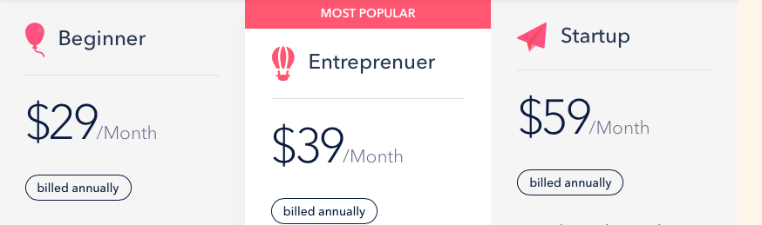

Monthly ($39, $59, $99/month)

Yearly ($29, $39, $69/month)

Beginner

* 50 Messenger Bot
* 10 E-Commerce Stores
* 5 Facebook Accounts
* 10 Facebook Pages
* Drag & Drop Email Template Builder
* 5 Email Autoresponder
* SMS Broadcast
* 4 Social Poster
* Comparison Marketing

Entrepreneur

* 100 Messenger Bot
* 50 E-Commerce Stores
* 10 Facebook Accounts
* 50 Facebook Pages
* Drag & Drop Email Template Builder
* 5 Email Autoresponder
* SMS Broadcast
* 7 Social Poster
* Comparison Marketing

Startup

* Unlimited Messenger Bot
* Unlimited E-Commerce Stores
* 20 Facebook Accounts
* Unlimited Facebook Pages
* Drag & Drop Email Template Builder
* 5 Email Autoresponder
* SMS Broadcast
* 7 Social Poster
* Comparison Marketing

**Compare Plan Features**

(note:- all these plans price will change as per the tab above i.e monthly or yearly and so as the text below price like billed yearly or billed monthly)

|  |  |  |  |
| --- | --- | --- | --- |
| Plan & Features | Beginner  $29/Month  Billed annually | Entrepreneur  $39/Month  Billed annually | Startup  $69/Month  Billed annually |
| Messenger Bot | 50 | 100 | Unlimited |
| E-Commerce Stores | 10 | 50 | Unlimited |
| Facebook Accounts | 5 | 10 | 20 |
| Facebook Pages | 10 | 50 | Unlimited |
| Drag & Drop Email Template Builder |  |  |  |
| Email Autoresponder | 5 | 5 | 5 |
| SMS Broadcast | 8 | 8 | 8 |
| Apps Integration | 10+ | 15+ | 25 |
| Social Poster |  |  |  |
| Supported social networks |  | youtube, wordpress, blogger, reddit | youtube, wordpress, blogger, reddit |
| Comparison Marketing |  |  |  |
| Zapier Integration |  |  |  |
| Facebook Posting : Text/Image/Link/Video Post |  |  |  |
| Facebook Posting : Carousel/Slider Post |  |  |  |
| Facebook Posting : CTA Post |  |  |  |
| Social Poster - Account Import : Youtube |  |  |  |
| Stats & Analytics |  |  |  |
| Comment Automation : Auto Comment Campaign |  |  |  |
| Messenger Bot : Export, Import & Tree View |  |  |  |
| Messenger Bot - Persistent Menu |  |  |  |
| RSS Auto Posting |  |  |  |
| Email Support |  |  |  |
| GDPR Compliant |  |  |  |

**Frequently Asked Questions**

Q) Is there a free trial of the paid plans?

Answer) Yes! There is a 14-day free trial. You can simply contact us at [signup@botsuite.io](mailto:signup@botsuite.io) & get your trial credentials and use botsuite without any risk.

Q) What is the benefit of an annual plan?

Answer) The annual plan allows you to purchase botsuite access at lower rate and you will get exclusive access to new features added time to time without paying extra.

Q) Is my data safe?

Answer) Yes, your data is safe with us as our platform is GDPR complaint.

Q) Is there any cancellation fees?

Answer) No, we don’t charge any cancellation fees. You are free to cancel your subscription anytime.

Q) Can I create a messenger ecommerce store for any niche?

Answer) Yes, You can. You can build a restaurant order system via messenger, can build service booking system, appointment booking system in the messenger itself.

Join 20,000+ companies and individuals that are using Botsuite to market their brand.

Botsuite is a multichannel marketing platform that helps marketers, entrepreneurs and brands create marketing campaigns, automate customer acquisition, followup, email/sms marketing without any technical expertise.

Buttons - Get a demo Sign up Free